Ashbury Meadow Primary School
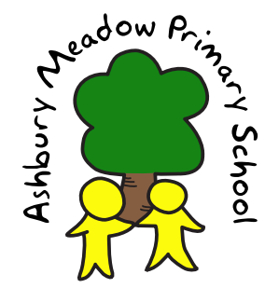

Rights Respecting School Policy

VALUES STATEMENT
Ashbury Meadow Primary School is a Level 1 Rights Respecting school. Children and adults work together to recognise and act upon the rights of the child within our school, our local community and the wider world. We believe that by understanding their own rights children learn to respect and value the rights of others.
At Ashbury Meadow children learn about rights through the United Nations Convention on the Rights of the Child (UNCRC). Children are taught that with rights comes respectful, responsible behaviour. We believe that learning should be fun and that by encouraging respect for each other and valuing opportunities available we all grow and learn together.
Ashbury Meadow Primary is currently a Level 1 Rights Respecting School.
Level 1 status was achieved in September 2017
Level 2 will be achieved in June 2018

UNCRC
The convention sets out the rights of children in 54 articles. These basic rights encompass survival, protection, development and participation.
The UNCRC is underpinned by four principles:
- non-discrimination
- commitment to the best interests of the child
- a right to life, survival and development
- respect for the views of the child

RIGHTS ARE UNIVERSAL AND CANNOT BE TAKEN AWAY
The main responsibility for ensuring that all children enjoy their rights lies with adults.
All rights are equally important.

RIGHTS RESPECTING VALUES UNDERPIN LEADERSHIP AND MANAGEMENT
- Development as a rights respecting school is an integral part of strategic planning.
- All decisions are taken in the best interests of the children.
- As school policies are reviewed, links with the values and principles of the UNCRC are made explicit.
- Recruitment and induction practices reflect our rights respecting ethos.

THE WHOLE SCHOOL COMMUNITY LEARNS ABOUT THE UNCRC
- Each year group learns about the UNCRC.
- Displays are explicitly linked to the UNCRC.
- Right of the month is a key feature at Ashbury Meadow with rights being linked to world events to give the children context and develop their awareness of global citizenship.
- All members of the community are encouraged to be ambassadors for children’s rights.
- Parents, governors and the wider community are included in our work as a Rights Respecting School.

THE SCHOOL HAS A RIGHTS RESPECTING ETHOS
- Charters are drawn up in consultation between children and adults and identify the rights that are most relevant to that situation together with the ways in which adults and children will act in order to ensure that these rights are respected.
- All members of the community model Rights Respecting language.
- The environment is safe physically and emotionally.
- Conflicts are resolved using restorative approaches where children are empowered to seek solutions to problems.

CHILDREN ARE EMPOWERED TO BECOME ACTIVE CITIZENS AND LEARNERS
- Pupils’ opinions and thoughts are sought, encouraged and respected in all aspects of school life.
- Pupil Leadership is an integral part of the school’s approach. Children are given opportunities to lead aspects of school life through a range of groups including: School Council, Ashbury Buds, Sports Leaders & Rights Team.
- Pupils are encouraged to see themselves as Global Citizens and are given opportunities to develop their knowledge and awareness of how they can have a positive impact on the world, now and in the future.

