Pupil Acceptable Use Policy for Remote Education
Date Written: November 2020
Revised : October 2023
If we need to learn from home:
1. We will learn using the applications in G Suite
2. We must only use our school account to log on and complete our home learning.
3. We can contact our class teachers between 8.30am and 4.00pm, but they might not be able to answer us straight away.
4. We will attend live lessons which are on our timetable and ask our parents to let school know if we are not able to join for any reason.
5. We will dress appropriately for live lessons (smart/casual) and if possible blur our backgrounds to avoid unnecessary distractions.
6. We will catch-up with any live lessons we have missed where content is made available (EG read slides from an assembly)
7. We will complete our learning in a shared space where there are grown-ups around to help me if I need it and make sure that this space is a quiet place to learn.
8. We will complete the work on our timetable each day and share it with our class teachers so that they can give us some feedback on how to keep getting better
9. We will tell our teachers if we are finding learning too difficult/ too easy so that they can adapt it for us.
10. We will remember that all our communications using our school accounts are monitored, and we will only write comments that respect others' rights.
11. We will remember our online safety rules when we are working and always tell a grown up if we see or hear anything that worries us.
12. We will only log into G Suite using our own username and password and never share our personal information with other people.
13. We will behave online like we do in the classroom and remember that our School values and class room charter still apply.
14. We will always check to make sure the camera is off on our device when we are not using it.
15. We will tell a teacher if we are worried about something whilst we are not in school, so Kathryn or Amie can contact us. We will do this by leaving our worry on a document under the ‘my concerns’ heading in our Google classroom.
Our school values:
Be kind and friendly
Show respect to others by keeping hands, feet and objects to yourself
Respect adults by following instructions
Walk around school quietly
Take care of yourself, respect each other and our school
Think before you speak, think before you act.
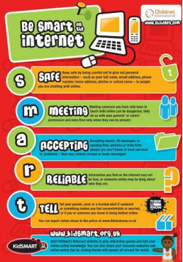

I agree to our acceptable use policy and will make sure I keep SMART on the internet

Signed:

Date:

