Ashbury Meadow E-Safety Rules

This is how we stay safe when we use computers:
- I will use activities that a teacher or suitable adult has told or allowed me to use
- I will take care of the computer and other equipment
- I will ask for help from a teacher or suitable adult if I am not sure what to do or if I think I have done something wrong
- I will tell a teacher or suitable adult if I see something that upsets me on the screen
- I know that if I break the rules I might not be allowed to use a computer / tablet
- I will immediately close any website I am unsure about
- I will not give out personal information and passwords
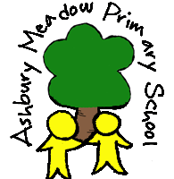
- I will not use chatrooms

